Topology of electrical systems

Main guidelines :
- Maximum reliability for vital systems
- Dashboard and monitoring reduced to only the necessary

Composition of the harness :
- DTA S80 ECU
- Gear control box, composed of an Arduino Mega and a custom shield sealed in a Polycaronate box aimed to control the brushless servomotor
- Dashboard control box, composed of an Arduino Mega sealed in an ABS box, aimed to transmit data between the CAN Bus and the dashboard
- Carbon dashboard, embeds all the necessary lights and buttons and minimizes the electronic elements sensitive to outdoor conditions.
- Littelfuse sealed hard-wired power distribution module, composed of simple relays and fuses
- Lightweight and compact SuperB LiFePO4 battery
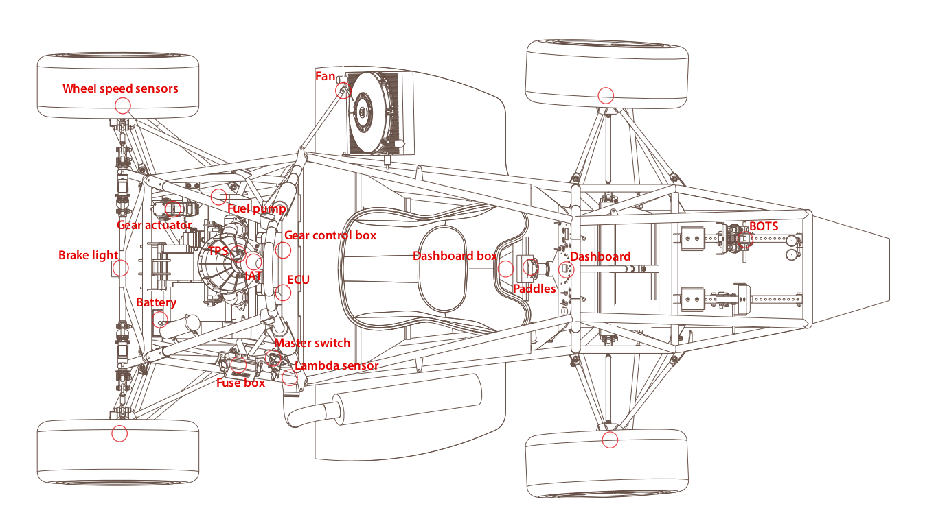
Vital systems are hard-wired in the harness whereas secondary data is transmitted through a CAN bus.

Data management

A CAN BUS is aimed to exchange data between the ECU, the gear control box, and the dashboard box.
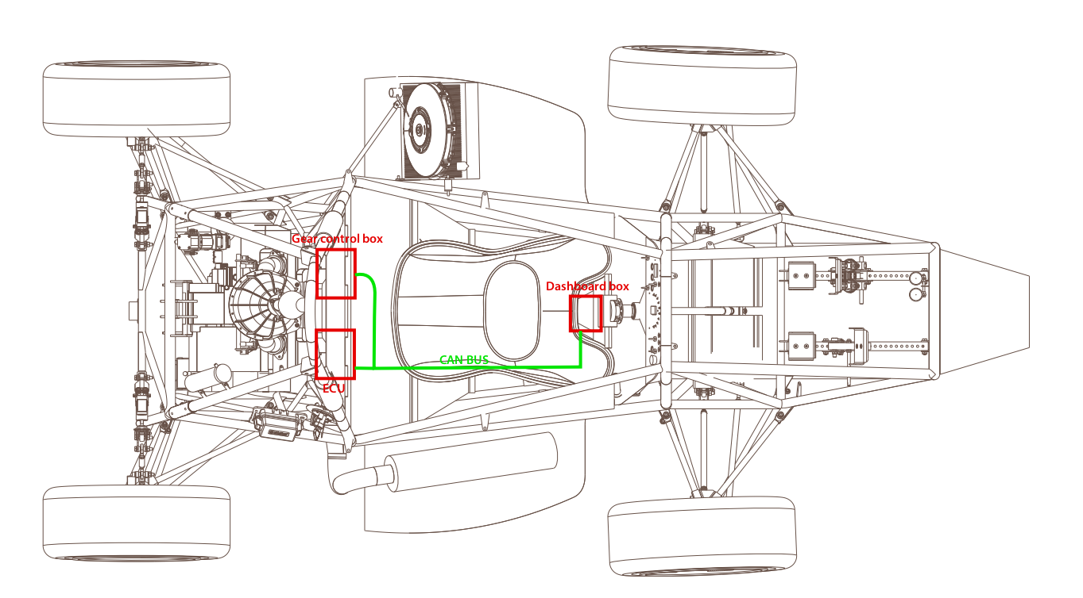

Emission and reception through CAN tabular
ECU | Dashboard box | Gear control box
⇧ Water temperature  ⇧ RPM  ⇧ Oil pressure | ⇧ Neutral button  ⇧ Servomotor homing button  ⇩  ⇩  ⇩  ⇩ | ⇩  ⇩  ⇧ Engaged gear

Hard-Wired data
- Gear shift
- Traction control, launch control, log switch and injection map selection buttons
- Shift light
- Engine start
- Fan control
- Neutral light

Dashboard composition

Mettre le PDF joint (en formqt paysage, c’est mieux)

